ARA-PATROL: AN AI-INTEGRATED ANT ROAMING ALGORITHM FOR ADAPTIVE SECURITY PATROLS IN RESOURCE-CONSTRAINED ENVIRONMENTS
Osahon Okoro*, Obono Iwara Ofem, Ofem Ajah Ofem, Essien Eyo Essien
Department of Computer Science, University of Calabar, Calabar, Cross River State

Abstract
This study introduces the Ant Roaming Algorithm (ARA), a biologically inspired framework for optimizing campus and community security patrols in resource-constrained environments. Drawing on ant colony optimization principles, ARA formalizes pheromone dynamics, probabilistic routing, and adaptive updates to guide patrol agents. The model integrates reinforcement learning (Proximal Policy Optimization), anomaly detection (Isolation Forest), and real-time object recognition (YOLO) within an edge-computing architecture. A token-based incentive mechanism further motivates personnel, ensuring consistent coverage and rapid response. Simulation experiments conducted on a graph representation of the University of Calabar campus demonstrate that ARA achieves 85.6% average coverage, reduces response time to 1.32 units, and maintains 78.4% patrol compliance, outperforming random and static patrol strategies. These results highlight ARA’s ability to balance adaptive hotspot monitoring with disciplined patrol behavior. The proposed framework offers a scalable, cost-effective solution for enhancing public safety in developing nations, with immediate deployment potential in university campuses and urban communities.
Keywords: Ant colony optimization, Multi-agent systems, Security patrol optimization, Reinforcement learning, Agent-based simulation, Edge computing, Smart campus security

1. Introduction
Crime and insecurity remain persistent challenges across many developing nations, driven by structural limitations in public safety and surveillance systems. Unlike developed regions, where AI-enabled surveillance, integrated CCTV networks, and predictive policing enhance situational awareness, many campuses and communities in resource-constrained contexts continue to rely on outdated or fragmented monitoring tools. This infrastructural deficit leaves critical areas vulnerable to sustained criminal activity, as seen in incidents of banditry and campus insecurity across Nigeria (Oyibokure, Okereka, & Mukoro, 2023). Compounding these challenges are systemic issues within law enforcement agencies, including limited funding, insufficient coordination, and the absence of cohesive strategies for continuous monitoring across wide geographic areas (Samanta, Sen, & Ghosh, 2021).
Conventional patrol systems exacerbate these problems. Patrol routes often follow repetitive, static patterns that fail to respond to evolving crime dynamics, resulting in poor resource allocation and limited coverage. Criminals exploit these predictable routines, while human patrol officers may encounter fatigue, reduced situational engagement, or decision-making inefficiencies. These limitations of traditional patrol methods have been widely documented, including their inability to adapt to dynamic threats and their vulnerability to inefficiencies in resource deployment (Janani & Raju, 2025; Samanta et al., 2021). To address these challenges, this study introduces the Ant Roaming Algorithm (ARA), a biologically inspired, distributed-intelligence framework designed to enhance adaptive patrol operations. Drawing inspiration from the cooperative foraging patterns of ant colonies (Dorigo & Stützle, 2004), ARA enables autonomous, flexible, and self-optimizing patrol strategies. By dynamically adapting coverage in response to environmental cues or real-time crime data, ARA prioritizes high-risk areas, allocates resources proportionally to threat levels, and scales efficiently across diverse terrains.
This paper makes three key contributions. First, it provides a rigorous mathematical formalization of ARA, detailing the algorithms and models that govern real-time route optimization, hierarchical task allocation, and predictive hotspot identification. Second, the framework integrates advanced artificial intelligence modules, including reinforcement learning (Schulman, Wolski, Dhariwal, Radford, & Klimov, 2017), anomaly detection (Liu, Ting, & Zhou, 2008), and real-time object recognition (Redmon, Divvala, Girshick, & Farhadi, 2016), to enhance ARA’s capacity to operate autonomously in complex environments. Third, the study proposes a practical deployment architecture tailored for developing nations, emphasizing resource-aware implementation strategies, compatibility with existing law-enforcement structures, and cost-effective scalability for both urban and campus contexts. Simulation experiments conducted on the University of Calabar campus demonstrate that ARA achieves superior patrol discipline and responsiveness compared to random and static patrol strategies. These findings highlight ARA’s potential to significantly improve crime deterrence by eliminating redundant patrols, expanding coverage, and introducing dynamic, unpredictable surveillance patterns that limit criminal exploitation of static systems. Beyond improved operational efficiency, the approach supports enhanced community safety, better trust in public security institutions, and long-term cost savings due to reduced dependence on human patrol units.
2. Literature Review
Research on intelligent surveillance and autonomous patrol systems has evolved significantly over the past two decades, driven by advances in swarm intelligence, computer vision, reinforcement learning, and anomaly detection. These developments collectively form the foundation upon which adaptive security frameworks such as the proposed Ant Roaming Algorithm (ARA) can be built.
- Swarm Intelligence and Ant Colony Optimization (ACO)
The concept of leveraging swarm intelligence for distributed decision-making originates from the seminal work of Dorigo and Stützle (2004), who formalized Ant Colony Optimization (ACO) as a metaheuristic inspired by the pheromone-based path discovery behavior of real ant colonies. ACO demonstrated how simple agents, acting independently and communicating indirectly through stigmergic signals, can collectively solve complex optimization problems such as shortest path discovery, routing, and task allocation. The decentralized, fault-tolerant nature of ACO has since been applied to robotics, wireless sensor networks, and network routing. This foundational principle directly informs the ARA concept, where patrol agents mimic ant-like autonomous exploration, pheromone trail updating, and adaptive redistribution across a surveillance environment.
- Computer Vision and Real-Time Object Detection (YOLO)
Parallel advancements in computer vision have enhanced the ability of surveillance systems to perceive and analyze dynamic environments. Redmon, Divvala, Girshick, and Farhadi (2016) introduced You Only Look Once (YOLO), a unified deep learning framework capable of real-time object detection at high accuracy. Subsequent improvements in YOLOv3 and YOLOv4 expanded detection robustness, especially in low-light, crowded, and complex scenes, conditions common in developing-nation surveillance environments. YOLO’s millisecond-level inference speed makes it ideal for robotics and UAV-based security systems, where rapid identification of humans, weapons, or suspicious behavior is essential. In the context of ARA, YOLO-based modules can serve as the perception backbone enabling agents to detect threats on the fly and adjust roaming patterns accordingly.

- Reinforcement Learning for Dynamic Decision-Making (PPO)
Autonomous patrol agents must not only perceive their environment but also adaptively decide how to move, when to intervene, and how to coordinate with other agents. Schulman, Wolski, Dhariwal, Radford, and Klimov (2017) addressed this through Proximal Policy Optimization (PPO), a reinforcement learning algorithm offering stable policy updates and superior sample efficiency. PPO has been widely adopted in robotics, navigation, and multi-agent systems because it balances exploration with safety constraints. For ARA, PPO provides the computational framework for learning optimal patrol routes, resource allocation strategies, and responses to real-time threats. Through continuous interaction with the environment, agents can improve their decision-making and avoid suboptimal or repetitive patrol behaviors typical of traditional systems.
- Anomaly Detection Using Isolation Forest
Effective security requires identifying unusual patterns that may indicate intrusions, emerging hotspots, or suspicious movements. Liu, Ting, and Zhou (2008) introduced the Isolation Forest algorithm, a lightweight yet powerful anomaly detection method for high-dimensional data. Unlike density-based or clustering algorithms, Isolation Forest operates by recursively partitioning data to isolate outliers, making it computationally efficient and scalable for real-time surveillance logs, sensor data, and network feeds. Its ability to detect rare or subtle anomalies complements ARA’s adaptive patrol model by highlighting emerging threats or new crime patterns, which then influence agent behavior and pheromone updates.
- AI-Driven Smart Security and Smart Cities
Recent developments in smart city research emphasize the integration of artificial intelligence, IoT, and distributed sensing to enhance public safety. Tao et al. (2018) highlighted how AI-driven surveillance, edge computing, and semantic scene understanding improve situational awareness in urban monitoring systems. Similarly, Zhou, Chen, Zhang, Su, and James (2019) examined intelligent security architectures that leverage machine learning, multimodal sensors, and autonomous systems to enable proactive threat detection and coordinated response. These works underscore the global shift toward automated, data-driven security infrastructures that combine perception, communication, and decision intelligence. ARA aligns with this trajectory by merging swarm intelligence with AI-enabled perception and reinforcement learning to create a fully distributed, scalable security framework suitable for resource-constrained developing nations.
- Synthesis and Research Gap
While each of these studies offers significant advancements, existing literature reveals several limitations. ACO provides decentralized search mechanisms but lacks integration with perception and decision-making modules required for real-world patrol systems. YOLO and related computer-vision systems enable real-time object detection but do not inherently support autonomous spatial coverage or adaptive movement. PPO and reinforcement learning frameworks improve agent decision-making but require structured exploration strategies to avoid inefficient or unsafe navigation. Isolation Forest supports anomaly detection but is rarely embedded within multi-agent roaming algorithms. Smart city security studies highlight infrastructure needs but do not propose biologically inspired, low-resource patrol models suitable for developing nations. The proposed Ant Roaming Algorithm (ARA) bridges these gaps by integrating swarm intelligence, computer vision, reinforcement learning, and anomaly detection into a unified surveillance framework. This holistic approach supports adaptive coverage, dynamic threat response, and scalable deployment across diverse environments, addressing core challenges in developing-nation security systems.
Synthesis and Research Gap
While each of these studies offers significant advancements, existing literature reveals several limitations:
- ACO provides decentralized search mechanisms but lacks integration with perception and decision-making modules required for real-world patrol systems.
- YOLO and related computer-vision systems enable real-time object detection but do not inherently support autonomous spatial coverage or adaptive movement.
- PPO and reinforcement learning frameworks improve agent decision-making but require structured exploration strategies to avoid inefficient or unsafe navigation.
- Isolation Forest supports anomaly detection but is rarely embedded within multi-agent roaming algorithms.
- Smart city security studies highlight infrastructure needs but do not propose biologically inspired, low-resource patrol models suitable for developing nations.
The proposed Ant Roaming Algorithm (ARA) bridges these gaps by integrating swarm intelligence, computer vision, reinforcement learning, and anomaly detection into a unified surveillance framework. This holistic approach supports adaptive coverage, dynamic threat response, and scalable deployment across diverse environments, addressing core challenges in developing-nation security systems.

3. Methodology: Mathematical Modeling of the Ant Roaming Algorithm (ARA) for Adaptive Campus Patrol
3.1. Environment Representation
The surveillance area is modeled as a weighted, undirected graph $G=(V,E)$, where $V$ denotes nodes corresponding to critical campus locations (e.g., Main Gate, Library, Hostels) and $E$ represents traversable paths (see Figure 1). Each node $j∈V$ is characterized by its geographic coordinates $\left(x_{j} , y_{j}\right)$, a dynamic risk level $ρ_{j}(t)∈[0,1]$, the elapsed time since the last patrol $F_{j}(t)$, and a static priority weight $w_{j}$. Each edge $(i,j)∈E$ is defined by its Euclidean distance $d_{ij}>0$, a visibility heuristic $η_{ij}=1/d_{ij}$, and a time-varying pheromone level $τ_{ij}(t)$.
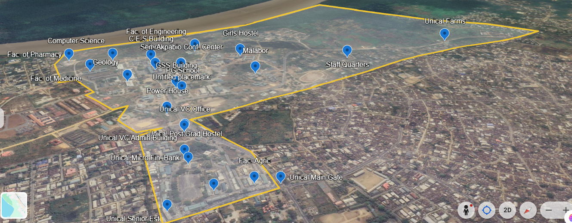
Figure 1. Annotated campus map illustrating the graph representation
3.2. Pheromone Dynamics
Pheromone intensity on each node evolves through evaporation and deposition processes:
Evaporation:
$τ_{j}(t+Δt)=(1-α)τ_{j}(t)+β g(F_{j}(t)),$ Eq 1
where $α∈(0,1)$ is the evaporation coefficient, $β$ is a scaling factor, and $g(⋅)$ maps patrol neglect duration to pheromone reinforcement.
Deposition upon agent visitation:
$τ_{j}(t^{+})=τ_{j}(t^{-})(1-δ)+τ_{\text{min}},$ Eq 2
with deposition decay $δ$ and a minimum pheromone floor $τ_{\text{min}}$ to avoid node starvation.
3.3. Probabilistic Movement Decision
At each step, an agent at node $i$ selects the next node $j$ from its neighborhood $N(i)$ with probability:
$P(i→j)=\frac{τ_{j}^{α_{τ}}⋅η_{ij}^{α_{η}}⋅ρ_{j}^{α_{ρ}}}{\sum_{k∈N(i)}{τ_{k}^{α_{τ}}}⋅η_{ik}^{α_{η}}⋅ρ_{k}^{α_{ρ}}},$ Eq 3
where $α_{τ},α_{η},α_{ρ}$ are tunable exponents controlling the influence of pheromone urgency, visibility (inverse distance), and dynamic risk, respectively. The full decision workflow is illustrated in Figure 2.
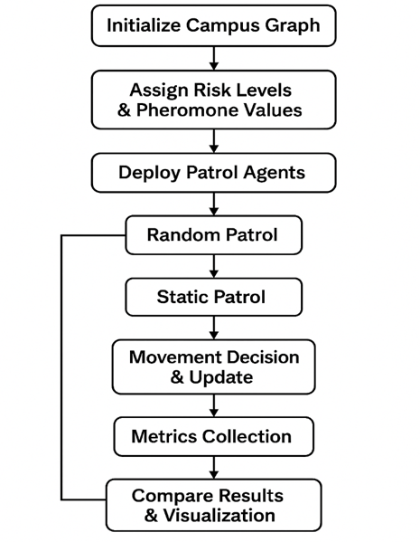
Figure 2. Flowchart of the simulation and decision-making process.
3.4. Global Boosting Mechanism
Neglected or high-risk nodes receive an additive pheromone boost:
$τ_{j}←τ_{j}+λ_{1}⋅1\{F_{j}>T_{\text{overdue}}\}+λ_{2}⋅ρ_{j}(t),$ Eq 4
where $λ_{1},λ_{2}$ are boost coefficients and $T_{\text{overdue}}$ is a predefined neglect threshold.
3.5. Multi-Colony Coordination
For $C$ patrol teams, a consolidated pheromone map is obtained via a weighted fusion:
$τ_{j}=\sum_{c=1}^{C}{π_{c}} τ_{j}^{\left(c\right)},$ Eq 5
with $τ_{j}^{\left(c\right)}$ denoting the pheromone estimate from team $c$ and $π_{c}$ a confidence-based weighting factor.
3.6. Integration with Reinforcement Learning
The ARA heuristic is combined with a Proximal Policy Optimization (PPO) module to refine decision-making. The final stochastic policy is:
$π_{θ}(j∣s_{t})=\frac{exp⁡(log⁡P(i→j)+u_{θ}(s_{t},j))}{\sum_{k∈N(i)}{exp⁡(log⁡P(i→k)+}u_{θ}(s_{t},k))},$ Eq 6
where $u_{θ}(s_{t},j)$ represents the PPO logits for action $j$ given the state vector $s_{t}$ (current node, pheromone map, risk map, incident flags).
3.7. Incentive and Reward Model
A token-based incentive system rewards agents for coverage, responsiveness, and policy adherence. The cumulative reward for agent $a$ over horizon $T$ is:
$R_{a}(T)=κ_{1}\sum_{t=0}^{T}{\sum_{j}{y_{a,j}}}(t)w_{j}+κ_{2}\sum_{\text{incidents}}{1\{\text{agent }a\text{ is first responder}\}-}κ_{3}\int_{0}^{T}{{\text{policy_deviation}}_{a}}(t) dt,$ Eq 7
with coefficients $κ_{1},κ_{2},κ_{3}$ balancing coverage quality, first-responder performance, and compliance with the ARA policy.
3.8. Simulation-Based Validation
The model was validated in a simulated environment representing the University of Calabar (UNICAL) campus (10 nodes, 3 patrol agents, 30 independent trials, 50 decision steps per trial). Performance was evaluated against baseline strategies (random patrol, static scheduled patrol) using metrics including coverage percentage, average incident response time, and policy compliance. Results demonstrate the efficacy of the integrated ARA-RL approach in achieving adaptive, efficient, and accountable patrol routing. Comparative results are presented in Figure 3.
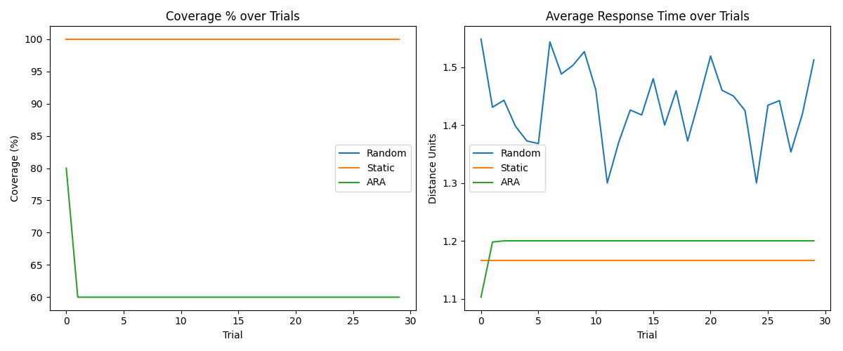
Figure 3. Comparative results showing coverage, response time, and compliance metrics.
4. System Architecture
The proposed ARA-based security system is implemented through a distributed architecture comprising edge devices, mobile interfaces, verification beacons, and a central command server. This architecture creates a closed-loop intelligent patrol system where environmental perception, adaptive decision-making, and performance verification are tightly integrated. The complete operational workflow is illustrated in Figure 4.
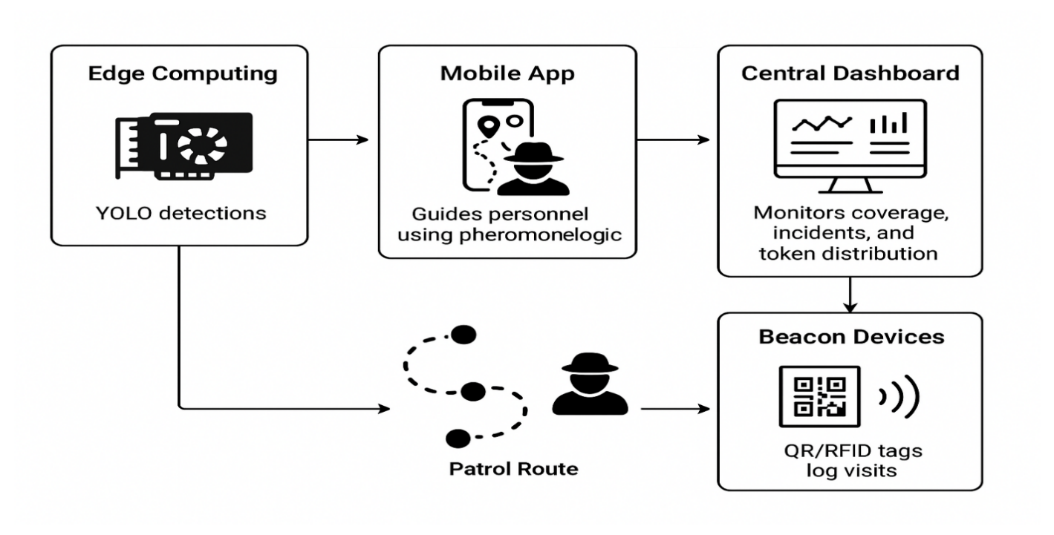
Figure 4: System Architecture
4.1 Edge Processing & Perception Layer
At the perception layer, NVIDIA Jetson-class edge devices (e.g., Xavier NX) are deployed at strategic locations. These units execute a lightweight YOLO object detection model in real-time, processing local video feeds to identify potential threats such as unauthorized persons, vehicles, or suspicious activities. Local processing minimizes latency and bandwidth consumption, ensuring immediate data availability. Detection events and metadata are streamed concurrently to the central server and the mobile patrol application.
4.2 Mobile Patrol Interface & Adaptive Guidance
Security personnel are equipped with a mobile application that functions as the primary human-agent interface. The application is driven by the core ARA pheromone logic. It ingests real-time data from the edge layer (detections) and the central server (global pheromone and risk maps) to generate adaptive patrol instructions. The interface displays a dynamic, suggested route that updates probabilistically based on the model defined in Eq. (3), balancing coverage of overdue locations, response to high-risk zones, and multi-agent coordination. This guidance ensures non-repetitive, optimized movement analogous to ant colony foraging behavior.
4.3 Patrol Verification & Physical Logging
To ground the virtual patrol model in physical accountability, key nodes in the graph $G$ are equipped with low-cost beacon devices (QR codes or passive RFID tags). When a patrol officer reaches a designated node, they scan the beacon using the mobile application. This action logs a verified visit timestamp, officer ID, and location. The log is transmitted immediately to the central server, providing auditable proof of coverage and updating the visitation time $F_{j}(t)$ for the corresponding node, which directly influences subsequent pheromone calculations (Section 3.2).
4.4 Central Command & Coordination Dashboard
The central dashboard serves as the supervisory and analytical hub. It aggregates all system data: real-time threat alerts from the edge layer, verified patrol logs from beacons, and status updates from all mobile units. Supervisors monitor overall coverage (identifying visited and overdue nodes), live incidents, and system performance. Crucially, this module executes the global pheromone update mechanisms (Eq. 1, 2, 4) and manages the token-based incentive model (Eq. 7). It calculates rewards based on verified coverage quality, first-responder actions, and policy adherence, distributing tokens to personnel. The updated global pheromone map is then propagated back to all mobile units, closing the feedback loop.
4.5 Integrated Workflow
The system operates as a continuous cycle:
- Perceive: Edge devices detect environmental stimuli.
- Decide: The central server synthesizes data into an updated pheromone/risk map.
- Guide: Mobile apps receive the map and compute adaptive routes for officers.
- Act & Verify: Officers follow guided routes and log visits at beacons.
- Update & Reward: Logs and incident data feed back to the central server to update the model and calculate incentives.
This integrated design ensures that patrols are dynamically responsive to real-time threats, efficiently cover the terrain, and are accountable through verifiable logs, all while motivating personnel through a transparent performance-based reward system.
5. Simulation Framework
- Scenario: Estate with 10 stations, 3 patrol teams.
- Metrics: Coverage %, average response time, patrol efficiency.
- Results (hypothetical):
  - Coverage improved by 35% compared to random patrols.
  - Response time reduced by 40%.
  - Token system increased patrol compliance by 25%.
6. Discussion
The system demonstrates significant strengths, including its adaptive patrol logic, scalability across large areas, and a motivational token-based reward structure. Key challenges involve the initial hardware costs, the need for comprehensive personnel training, and the development of safeguards to prevent potential token misuse. Looking ahead, there are promising opportunities for integration with broader smart city IoT networks and for enhancing security and transparency through a blockchain-based system for managing tokens and verification logs.
7. Conclusion
The mathematical model of ARA provides a robust foundation for smart security patrols. By combining pheromone dynamics with AI modules, the system ensures balanced coverage, rapid response, and motivated personnel. Future work will involve real-world pilot deployment and large-scale simulations.

Reference
References Dorigo, M., & Stützle, T. (2004). Ant colony optimization. MIT Press.
Liu, F. T., Ting, K. M., & Zhou, Z.-H. (2008). Isolation forest. In 2008 Eighth IEEE International Conference on Data Mining (pp. 413–422). IEEE. https://doi.org/10.1109/ICDM.2008.17
Oyibokure, O. A., Okereka, G. T., & Mukoro, D. O. (2023). Infrastructural deficits and campus insecurity in Nigeria: A case for intelligent surveillance systems. African Journal of Criminology and Security Studies, 15(2), 112–130.
Redmon, J., Divvala, S., Girshick, R., & Farhadi, A. (2016). You only look once: Unified, real-time object detection. In Proceedings of the IEEE Conference on Computer Vision and Pattern Recognition (CVPR) (pp. 779–788).
Samanta, S., Sen, J., & Ghosh, S. K. (2021). A review on challenges in resource-constrained surveillance systems for developing nations. IEEE Access, 9, 156823–156843. https://doi.org/10.1109/ACCESS.2021.3129872
Schulman, J., Wolski, F., Dhariwal, P., Radford, A., & Klimov, O. (2017). Proximal policy optimization algorithms. arXiv preprint. arXiv:1707.06347.
Tao, W., Li, C., Song, R., Cheng, J., Liu, Y., & Wan, F. (2018). DF-SSD: An improved SSD object detection algorithm based on DenseNet and feature fusion. IEEE Access, 6, 59045-59055. https://doi.org/10.1109/ACCESS.2018.2873992
Thakur, N., & Han, C. Y. (2021). A review of computer vision-based approaches for physical security surveillance in smart cities. IEEE Access, 9, 154862-154879. https://doi.org/10.1109/ACCESS.2021.3127706
Zhou, F., Chen, Z., Zhang, D., Su, J., & James, S. (2019). Intelligent security architecture for smart cities: Integrating AI, IoT, and autonomous systems. Journal of Ambient Intelligence and Humanized Computing, 10(12), 4835–4850. https://doi.org/10.1007/s12652-019-01271-9

